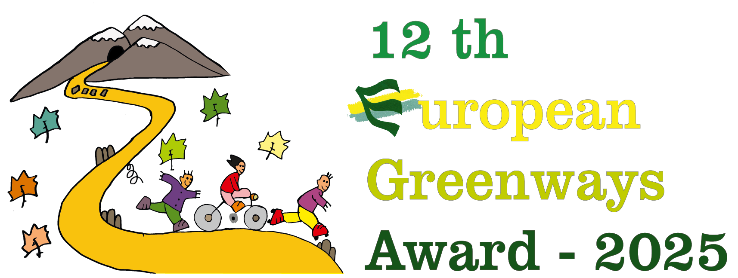 | APPLICATION FORM
12th European Greenways Award
Excellence Awards category

1. General information

1.1 Candidacy

Greenway’s Name:

Short description (maximum 5 lines):

1.2 Details of applicant
Entity name (full legal name):

Abbreviated name
(if applicable):
Legal status:

Name and title of the person responsible for the technical aspects:
Name and title of the legal representative:
Address - Street & nº:

City
Postal code
Country
e-mail:
Phone: (including international code):
Web site:
Social Networks
2. Summary description of the greenways implementation

2.1 General characteristics of the greenway

Geographical situation (Country, region, town - please give as much detail as possible)

Greenway’s begin at:
Greenway’s end at:
Length: (km)
Width: (m)
Surface (hard, smooth) pls indicate:
Average gradient: (%)
Towns and areas crossed:
Authorized users:
(if possible, with estimation of user percentages cycling, walking, wheeling):
Kind of usage:
(leisure, tourism, daily trips, etc.)
(if possible with estimation of user percentages):
Investment value and origin: (EUR)
Facilities offered to users of the greenway:
Type of previous use of the infrastructure (canals, railways):
Web site:
Social Networks

2.2 Summary description of the greenways implementation

a) Description of the greenway’s context (environment, population, economy, social, tourism, health, etc.) (Maximum 20 lines)

b) Description of the implementation (Maximum 25 lines)

c) Dates & figures of implementation (schedule, date of completion of the works, date/period of activities, budget, employs, users …) (Maximum 20 lines)

d) What was the role of your organisation in the implementation? (Maximum 10 lines)

e) Please list all the other organisations involved and mention the role they played during the process. (Maximum 10 lines)

3. Why is your greenways implementation exemplary?

3.1 Explain why the implementation is exemplary (Maximum ½ page)

3.2 Achievements & results of this implementation. Please include specific figures (from surveys counters, …) (Maximum ½ page)

3.4 Other relevant aspects (Maximum 10 lines)

4 Photo annex

A minimum of 10 and a maximum of 20 photos must be submitted to illustrate the achievements of each candidate. Photos must be submitted with full copyright information and authorisation, and ready for web publication. (Photos must be at least of 300 ppp resolution and minimum size of 21cm x 15cm).

Photos must be sent electronically jointly with the application form to: award2025@aevv-egwa.org

The deadline ends on Wednesday 21 May 2025. Photos must be sent with clear reference to their candidacy.

5. Map file of the greenway
A map of the greenway allowing clear location should be included in pdf format and a file in kml format or other standard format as gpx will be highly appreciated.

6. Supplementary information

The submission of other additional documents that could be helpful in evaluating your application is voluntary but highly appreciated: brochures, videos, evaluation reports, webs links, etc. and can be sent in any language.

Supplementary information must be sent via e-mail using eventually a service for large file transfer to: award2025@aevv-egwa.org

Any supplementary information must be received by Wednesday 21 May 2025at the latest to the address below.

7. Declaration of the applicant

Authorise EGWA to use information enclosed in this application in the preparation of documents associated with the Award and EGWA actions
Declare that I have read and accept the rules and terms of the Award
Certify that all the enclosed information is correct

Date :

Deadline for reception of the candidacies: Wednesday 21 May 2025
e-mail: award2025@aevv-egwa.org

www.europeangreenwaysaward.org

